**Experiments**

These experiments can either be done by constructing your own model using STELLA, or by downloading a [pre-made version](http://www3.geosc.psu.edu/~dmb53/DaveSTELLA/Glaciers/), or by working with [a version that runs online](https://forio.com/simulate/dmb53/ice-sheet1/simulation/).

To begin with, make sure that the Milankovitch orbital variations of insolation are turned off so they do not impact the model.

**Experiment 1: Steady State? Response Time?**

In this first experiment, let’s see what happens to the glacier’s length over time with some reasonable initial conditions.

**Time Specs:**

Run from -300,000 to -200,000 years, with a DT of 200 and Runge-Kutta 4.

**Model Parameters:**

accumulation_rate = 1.2 { m/yr}

epsilon = .24 { ratio of rates }

initial_grounding_line = -400 {km}

initial_length_km = 400 {km starting length}

lambda = 14 {ice strength parameter }

slope = 0.002

Be sure that the **Milank switch** is turned off for this experiment.

a) Before running the model, try to predict what will happen to the ice sheet. Will it find a steady state, or will it just shrink to nothing or will it grow indefinitely? Then run the model and explain what happens.

b) Now, change the initial length to 3000 km — a very large ice sheet in this case. Will it find a steady state again? Will it have the same steady state length as in the first case? At the start, do you think that the accumulation rate times accumulation area will be greater than or less than the ablation rate times the ablation area?

c) How quickly does the ice sheet get into its steady state? How fast can the glacier grow and shrink? In systems analysis, this is called the *response time*, and is often defined as the time it takes a system to accomplish about 2/3 of its change to the eventual steady state (so it really only applies to systems that tend toward a steady state). In the case of our glacier, you can find the difference in length between the steady state length and the starting length — then find the point in time when about 2/3 of this change has been accomplished; that is your response time.

Use the model set-up and results from the first experiments (a & b) to estimate the response time, giving the result in kyr.

**Experiment 2: Crossing the Threshold to Rapid Melting**

In the above experiment, we looked at 2 initial lengths and found that in both cases, the glacier evolved into a steady state length, where the accumulation area added was equal to the ablation area removed. Now, let’s explore a wider range of initial lengths, which will reveal an interesting change. Start with the same model set-up as in 1a, where the initial length was 400 km. Be sure that the **Milank switch** is turned off for this experiment.

a) Run the model, and you should see the glacier grow to a length of about 2100 km and then level off, having reached a steady state.

b) Now, decrease the initial length to 300 km. What length does the glacier end up at?

c) Now, decrease the initial length to 200 km. What length does the glacier end up at? Describe, briefly, what happens to the glacier in this case. Note that in (a), the glacier decelerates as it approaches the steady state — it gets there very gradually. How does this deceleration of (a) compare with the behavior in this case?

d) Now increase the initial length to 210 km. What length does the glacier end up at? Describe, briefly, what happens to the glacier in this case.

e) It should be clear to you that there is a threshold in the initial length that separates two very different behaviors and different outcomes. Fiddle around with the initial length until you find the threshold (within 1 km is fine).

**Experiment 3: Changing the Grounding Line**

Now let’s see what happens if we change the position of the grounding line, which is shown graphically below, shifted to the left (towards more negative values):

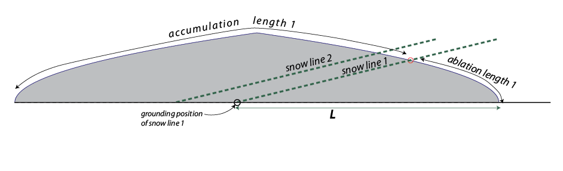

This is kind of like imposing a warming on the glacier. Start with the same model set-up as in 1a:

**Time Specs:**

Run from -300,000 to -200,000 years, with a DT of 200 and Runge-Kutta 4.

**Model Parameters:**

accumulation_rate = 1.2 { m/yr}

epsilon = .24 { ratio of rates }

initial_grounding_line = -400 {km}

initial_length_km = 400 {km starting length}

lambda = 14 {ice strength parameter }

slope = 0.002

Be sure that the **Milank switch** is turned off for this experiment.

a) Run this model to act as a control, taking note of the ending length and the general behavior. Then shift the grounding line to -500 km. Make a prediction about what will happen, then run the model and describe how this change has affected the glacier.

b) Now shift the grounding line to -300 km and make a prediction about how this will affect the glacier, then run the model and describe how this change has affected the glacier.

**Experiment 4: Changing the Ice Strength (l)**

Now we will investigate the affect of changing the ice strength parameter (l, which has as its main variable the critical shear stress for flow of the ice. If we lower l, then we are effectively lowering the critical shear stress, making it easier for the ice to flow. This would mean that with a lesser thickness and/or a shallower slope, the ice will flow. To begin, we will use the standard set-up from experiment 1a, where l is set to a value of 14. Run this “control” model first, and take note of the ending length and maximum thickness of the glacier. Be sure that the **Milank switch** is turned off for this experiment.

a) Change l to 12, thus making the ice flow more easily. Make a prediction about what this will do to the glacier in comparison with our control. Will the glacier grow to a greater or lesser length relative to the control? Will the height be lesser or greater?

b) Run the model and describe what happens and how the results compare with your predictions.

c) Now change to 10, and make a prediction. Then run the model and describe what happens and attempt to explain why it happens.

**Experiment 5: Ratio of Accumulation and Ablation (e)**

How will changing the ratio of accumulation and ablation (melting) rates affect the growth of the ice sheet? The model parameter called epsilon (e) controls this ratio. We will again use the model set-up from 1a as our control; here e is set at 0.24. First run this model to recall what happens to the length. Be sure that the **Milank switch** is turned off for this experiment.

a) Now change epsilon to 0.28. Remember that the ablation rate is equal to the accumulation rate divided by epsilon. What will changing epsilon to a larger value do to the ablation rate — make it greater or lesser than the control? Predict how this change will affect the equilibrium length of the glacier, and explain your reasoning.

b) Then, run the model and describe what happens, and explain why the glacier responds this way.

c) Now change epsilon to 0.20. How will this change the ablation rate relative to the control, and how will this affect the growth of the glacier?

d) Run the model and then describe what happens, and explain why the glacier responds this way.

**Experiment 6: Changing the Slope of the Snowline**

What will happen if the slope of the snowline increases? It is already set to a very low value of 0.002. First, let’s visualize what this would do to the glacier:

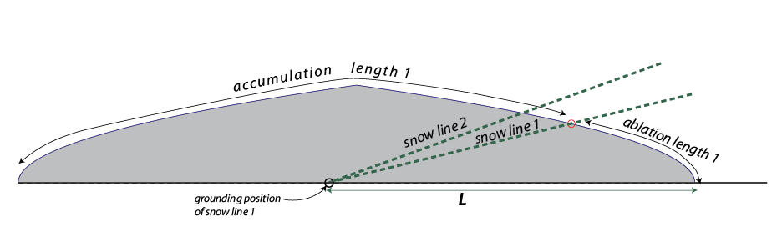

You can see that it will shorten the accumulation length and increase the ablation length. So, what will this do to the growth of the glacier?

As before, we begin with the model set-up for 1a, and then run this model to remind ourselves of the control case. *Take note of the beginning ablation length in the control.*

a) Change the slope slightly to 0.0022. First make a prediction about how this will affect the growth of the glacier relative to the control.

b) Run the model and explain what happens and why it happens. How does the beginning ablation length of this model compare with the control? How did the results compare with your prediction?

c) Now increase the slope even more to 0.0024. Run the model and describe what happens and why.

**Experiment 7: Orbital Forcing**

Now, we will connect the orbital forcing to the model by turning on the **Milank switch**. For the web-based version, we will now shift to a [different model](http://forio.com/simulate/dmb53/ice-sheet-milank/simulation/) that runs for the full 300 kyr (we’ve just been running 100 kyr so far). First restore all the parameters to the way they were for experiment 1a. Now, with the Milank switch turned on, the changing summer insolation due to orbital variations will force the grounding line position to move back and forth. Higher insolation pushes the groundling line position to the north (toward more negative values, while a decrease in insolation moves the grounding line to the south (more positive values). As you should know by now, moving the grounding line position will cause the glacier to advance and retreat.

Run the model and plot the length in km and Qt (the orbitally controlled variation in summer insolation), and study the relationship between the peaks and troughs in Qt and the size of the ice sheet.

a) Study the relationship between the glacier’s length and Qt (the insolation over time). Are they perfectly in sync, or does one seem to lag the other?

b) What is the lag time in kyr of the ice sheet relative to Qt?

c) How consistent is this lagtime?

d) What is the range of variation in the length of the glacier in km? For comparison, the Laurentide ice sheet expanded and contracted about 25° of latitude from it’s center of mass (x=0) and there are 111 km per degree of latitude.

e) Now compare the ice sheet length with the SPECMAP record of del18O, which is partly a measure of ice volume and partly a measure of temperature — higher values represent more ice and colder temperatures. How well do they agree? How similar or dissimilar are the times of the peaks and troughs?

f) Look at the most recent 10 kyr of the model. How is Qt changing during this time, and how does the model glacier respond? What does this suggest might be happening at the present time if we were not increasing the greenhouse effect through elevated CO2 levels — entering another small glaciation or holding steady or moving to a warmer interglacial?